1. Stakeholder Analysis & Prioritization
Stakeholders
- Marketers: Need custom links, branded domains, campaign analytics.
- App Developers: Need stable APIs, automation, integrations.
- End Users: Require fast global redirects and reliable uptime.
- Analytics Consumers: Need aggregated click insights.
- Security/Compliance: Need abuse controls, domain safety, and governance.
Prioritization
Priority | Stakeholder Need
Critical | Redirect latency, correctness, availability
High | Accurate analytics, strong API reliability
Medium | Custom alias features, dashboard polish
Low | Advanced segmentation, export tooling

2. Functional Requirements
- Create Short Link
  - Auto-generated key or custom alias
  - TTL, tags, optional metadata
- Resolve Link (Redirect)
  - GET /s/{id} → 302 redirect
  - Must be globally fast (p95 < 50 ms)
- Track Clicks
  - Device → via User-Agent
  - Geography → via IP lookup
  - Referrer tracking
- Analytics
  - Total clicks, unique clicks
  - Time-series charts (hour/day)
  - Top countries/referrers/devices
- Admin Controls
  - Link deletion, TTL change
  - Disable malicious links
- API + Dashboard
  - CRUD for links
  - Analytics retrieval

3. Non-Functional Requirements
- Availability: 99.99% for redirects
- Performance: p95 < 50ms, p99 < 100ms
- Scalability: 1B+ clicks/day, 100k+ peak QPS
- Durability: Never lose link mappings
- Strong consistency for redirect mapping
- Eventual consistency for analytics
- Security: AuthN/AuthZ, rate limiting, domain safety
- Global delivery: Anycast + multi-region

4. Constraints & Assumptions
- Redirect path is read-heavy (~95% handled by CDN).
- Analytics path is write-heavy and asynchronous.
- Multi-region replica latency varies → write operations centralized.
- Analytics can tolerate 1–5 minute delay.

2. Architecture & Diagrams:-

2.1 System Context Diagram (Simplified ASCII)

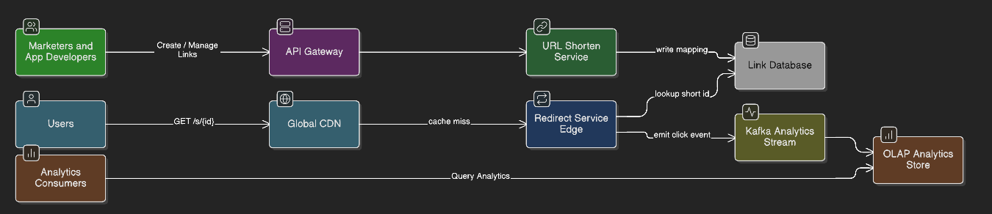2.2 Use-Case Diagram
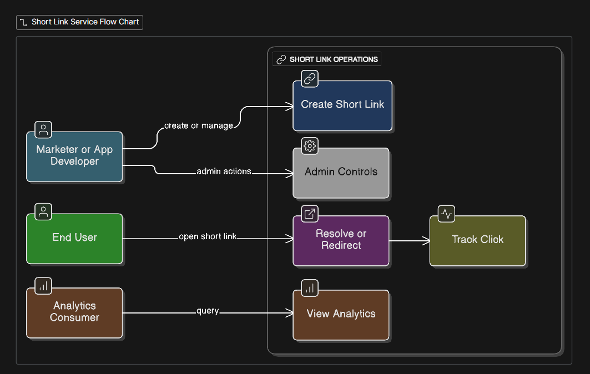

2.3 Sequence Diagram – Redirect
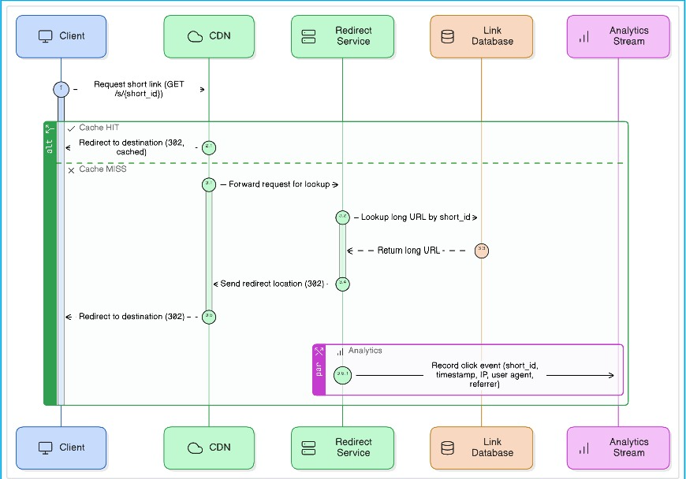

2.4 High-Level Architecture
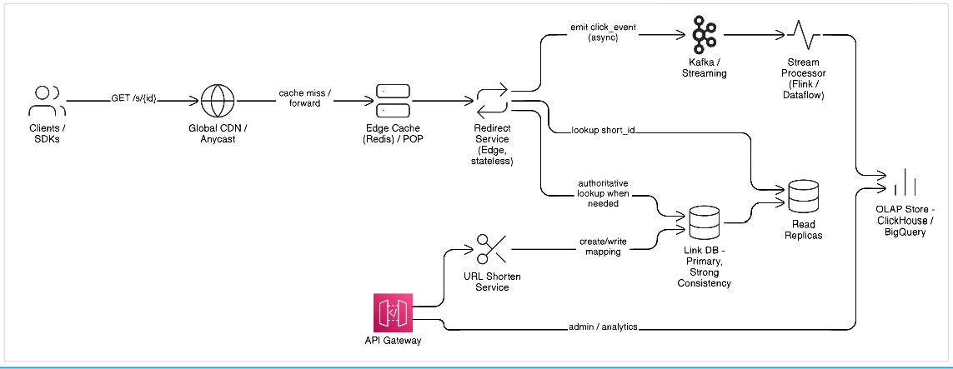

3. Engineering Notes

3.1 Capacity Planning
Assumptions
- 100M short links
- 1B clicks/day → ~12k clicks/sec avg
- Peak traffic → 100k+ QPS
Cache Efficiency
- CDN handles ~95%
- Edge cache handles ~90% of remaining 5%
- DB receives ≈ 0.5% of total traffic (~500 QPS)
Data Volume
- Raw analytics: 1B events × 200 bytes ≈ 200 GB/day
- OLAP compression reduces to 40–60 GB/day

3.2 API Specs
POST /v1/links
Request:
{ long_url, custom_alias?, ttl?, metadata? }
Response:
{ short_id, short_url }
GET /s/{short_id}
Returns 302 redirect.
GET /v1/links/{id}/stats
Returns analytics aggregates.

3.3 Data Model

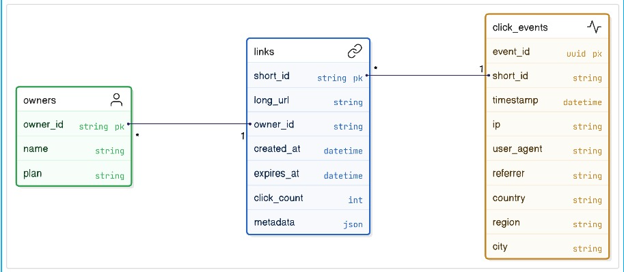3.4 Consistency
- Link resolution → Strong consistency
- Analytics → Eventual consistency (1–5 mins)
- Cache invalidation via TTL + purge API

3.5 Caching & Indexing
- CDN caching: 30–60 seconds
- Edge Redis caching: 1–24 hours
- Local LRU cache: microsecond lookups
- Index:
  - PK: short_id
  - Secondary index: owner_id

3.6 Rate Limiting
- Per-IP throttling
- Per-token API limits
- Custom alias namespace protection
- Malicious domain blocklist

3.7 Resiliency
- Circuit breakers around DB + Kafka
- Retry with exponential backoff
- Regional failover through Anycast routing
- Redirect service continues even if analytics pipeline is degraded

3.8 Observability
- Metrics: latency, QPS, cache hit-rate, DB latency, stream lag
- Logs: structured JSON with PII redaction
- Traces: OpenTelemetry across redirect → DB → analytics

4. Quality Targets & Trade-Offs

4.1 SLOs
Category | Target
Redirect availability | 99.99%
Redirect latency p95 | < 50ms
Analytics freshness | 95% < 5 minutes
API availability | 99.9%

4.2 Scalability Plan
- Horizontal scaling of stateless services
- Sharding link DB by short_id prefix
- Kafka partitioning by short_id hash
- OLAP partitioning by date + hash
- CDN/edge expansion to lower global latency

4.3 Trade-Off Discussion
- Strong consistency increases redirect correctness, but adds write latency from remote regions.
- Eventual consistency in analytics allows massive scale at lower cost.
- CDN caching drastically improves performance but requires purge workflows.
- Primary-region writes simplify correctness; replicas handle global reading.

